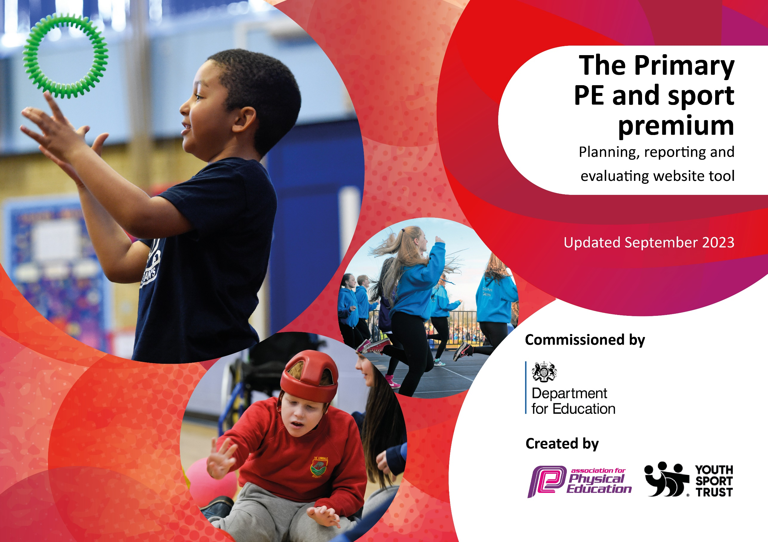

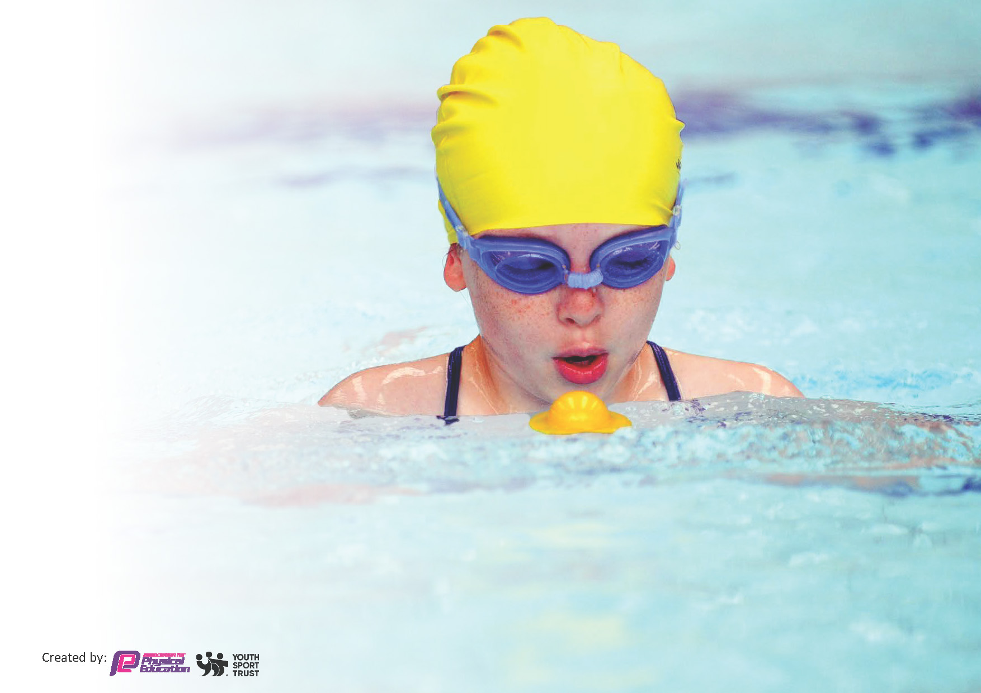
This template can be used for multiple purposes:
by:
- It enables schools to effectively plan their use of the Primary PE and sport premium
- It helps schools to meet the requirements (as set out in guidance) to publish information on their Primary PE and sport premium
- It will be an effective document to support Ofsted inspections enabling schools to evidence progress in Physical Education (PE) and evidence swimming attainment, which forms part of the PE National Curriculum. We would recommend schools consider
the Intent, Implementation and Impact of any spend, as examined within the Education Inspection Framework.

It is important that your grant is used effectively and based on school need.

Schools must use the funding to make additional and sustainable
improvements to the quality of the PE, School Sport and Physical Activity (PESSPA)
they offer. This means that you should use the Primary PE and sport premium to:

- Build capacity and capability within the school to ensure that improvements made now will benefit pupils joining the school in future years
- Develop or add to the PESSPA activities that your school already offers.

The Primary PE and sport premium should not be used to fund capital spend projects; the school’s core budget should fund these. Further detail on capital expenditure can be found in the updated Primary PE and sport premium guidance.

Review of last year’s spend and key achievements 2024-2025

Activity/Action | Impact | Comments
To support the OPAL  program to improve  sport and activities at  break and lunchtime,  including the  purchasing of  Equipment.  To provide year 6  students with any top  up swimming lessons.  To offer the children of  Year 6 a School  Residential Trip | Students’ physical engagement has improved with new resources and OPAL stations created through funding. External coaches were also employed to offer extracurricular activities after school and at lunchtime.  Swimming lessons did not need to be topped up. Hence, no money was spent.  All 28 children attended the year 6 residential which was funded through SP. | Parents helped with an open day to create more stations, which was very effective.

Key priorities and Planning
2025-2026

Action – what are you planning to do | Who does this action impact? | Key indicator to meet | Impacts and how sustainability will be achieved? | Cost linked to the action
Introduce lunchtime and afterschool sport sessions/activities for pupils. | Lunchtime supervisors / teaching staff, coaches - as they need to lead the activity  pupils – as they will take part. | Key indicator 2 -The engagement of all pupils in regular physical activity – the Chief Medical Officer guidelines recommend that all children and young people aged 5 to 18 engage in at least 60 minutes of physical activity per day, of which 30 minutes should be in school.  Key indicator 4: Broader experience of a range of sports and activities offered to all pupils. | More pupils meeting their daily physical activity goal, more pupils are encouraged to take part in PE and Sport Activities. | £6,972 costs for additional coaches to support lunchtime and afterschool sessions.

CPD for teachers. | Primary generalist teachers. | Key Indicator 1: Increased confidence, knowledge, and skills of all staff in teaching PE and sport.  Key indicator 5: Increased participation in competitive sport. | Primary teachers more confident to deliver effective PE supporting pupils to undertake extra activities inside and outside of school, including teaching water safety and swimming and as a result improved % of pupil’s attainment in PE. | £1,944 for 2 ECT 2 teachers
To offer the children of  Year 6 a School  Residential Trip | Year 6 pupils | Key indicator 2 -The engagement of all pupils in regular physical activity – the Chief Medical Officer guidelines recommend that all children and young people aged 5 to 18 engage in at least 60 minutes of physical activity per day, of which 30 minutes should be in school.  Key indicator 4: Broader experience of a range of sports and activities offered to all pupils. | To make sure the children of  year 6 are experiencing  something new. To  encourage pupils to take on  leadership or volunteer roles  that support sport and  physical activity outside of  school. They will be trying  new sports and activities that  are not available within our  local area. | £5,250
To purchase more resources for OPAL | All pupils of the Academy | Key indicator 2 -The engagement of all pupils in regular physical activity – the Chief Medical Officer guidelines recommend that all children and young people aged 5 to 18 engage in at least 60 minutes of physical activity per day, of which 30 minutes should be in school.  Key indicator 4: Broader experience of a range of sports and activities offered to all pupils. | More pupils meeting their  daily physical activity goal,  more pupils encouraged to  take part in PE and Sport  Activities. | £3,833

Key achievements 2025-2026
This template will be completed at the end of the academic year and will showcase the key achievements schools have made with their Primary PE and sport premium spending.

Activity/Action | Impact | Comments

Signed off by:

Head Teacher: | Charley Minter
Subject Leader or the individual responsible for the Primary PE and sport premium: | Charley Minter – Principal
Governor: | Steve Shore
Date: | 31.07.25

